Given an integer array nums sorted in non-decreasing order, return an array of the squares of each number sorted in non-decreasing order.

Example 1:
Input: nums = [-4,-1,0,3,10]
Output: [0,1,9,16,100]
Explanation: After squaring, the array becomes [16,1,0,9,100].
After sorting, it becomes [0,1,9,16,100].
Example 2:
Input: nums = [-7,-3,2,3,11]
Output: [4,9,9,49,121]

Constraints:
- 1 <= nums.length <= 10⁴
- -10⁴ <= nums[i] <= 10⁴
- nums is sorted in non-decreasing order.
Program:
class Solution {
public int[] sortedSquares(int[] nums) {
int n = nums.length;
int[] result = new int[n];

int left = 0;
int right = n - 1;

// Fill result from largest to smallest
for (int i = n - 1; i >= 0; i--) {
int leftSquare = nums[left] * nums[left];
int rightSquare = nums[right] * nums[right];

if (leftSquare > rightSquare) {
result[i] = leftSquare;
left++;
} else {
result[i] = rightSquare;
right--;
}
}

return result;
}
}
Output:

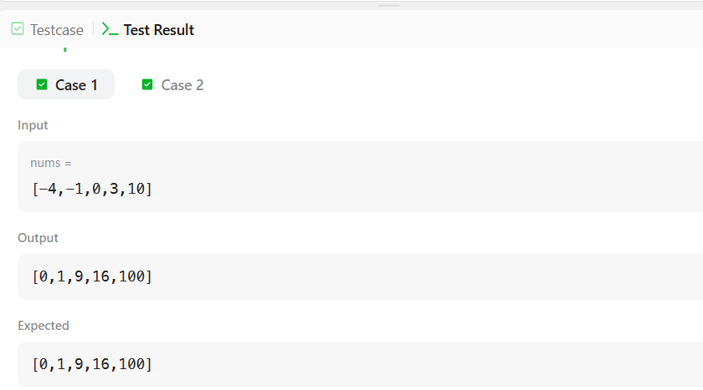

Given an array of integers nums, calculate the pivot index of this array.
The pivot index is the index where the sum of all the numbers strictly to the left of the index is equal to the sum of all the numbers strictly to the index's right.
If the index is on the left edge of the array, then the left sum is 0 because there are no elements to the left. This also applies to the right edge of the array.
Return the leftmost pivot index. If no such index exists, return -1.

Example 1:
Input: nums = [1,7,3,6,5,6]
Output: 3
Explanation:
The pivot index is 3.
Left sum = nums[0] + nums[1] + nums[2] = 1 + 7 + 3 = 11
Right sum = nums[4] + nums[5] = 5 + 6 = 11
Example 2:
Input: nums = [1,2,3]
Output: -1
Explanation:
There is no index that satisfies the conditions in the problem statement.
Example 3:
Input: nums = [2,1,-1]
Output: 0
Explanation:
The pivot index is 0.
Left sum = 0 (no elements to the left of index 0)
Right sum = nums[1] + nums[2] = 1 + -1 = 0

Constraints:
- 1 <= nums.length <= 10⁴
- -1000 <= nums[i] <= 1000
Program:
class Solution {
public int pivotIndex(int[] nums) {
int totalSum = 0;

// Calculate total sum
for (int num : nums) {
totalSum += num;
}

int leftSum = 0;

// Find pivot index
for (int i = 0; i < nums.length; i++) {
int rightSum = totalSum - leftSum - nums[i];

if (leftSum == rightSum) {
return i;
}

leftSum += nums[i];
}

return -1;
}
}

Output:
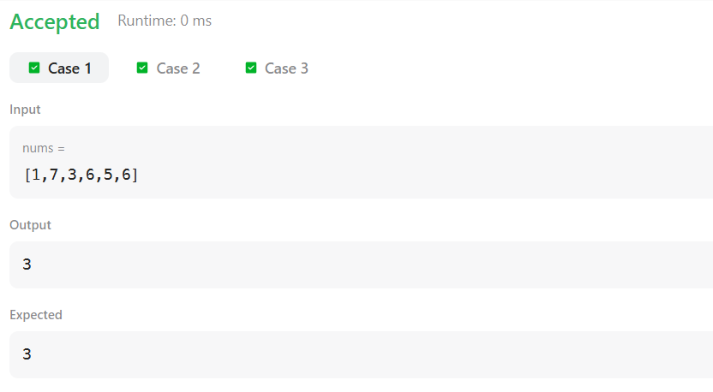Given an array nums. We define a running sum of an array as runningSum[i] = sum(nums[0]…nums[i]).
Return the running sum of nums.

Example 1:
Input: nums = [1,2,3,4]
Output: [1,3,6,10]
Explanation: Running sum is obtained as follows: [1, 1+2, 1+2+3, 1+2+3+4].
Example 2:
Input: nums = [1,1,1,1,1]
Output: [1,2,3,4,5]
Explanation: Running sum is obtained as follows: [1, 1+1, 1+1+1, 1+1+1+1, 1+1+1+1+1].
Example 3:
Input: nums = [3,1,2,10,1]
Output: [3,4,6,16,17]

Constraints:
- 1 <= nums.length <= 1000
- -10^6 <= nums[i] <= 10^6
Program:
class Solution {
public int[] runningSum(int[] nums) {
int sum = 0;

for (int i = 0; i < nums.length; i++) {
sum += nums[i];
nums[i] = sum;
}

return nums;
}
}
Output:
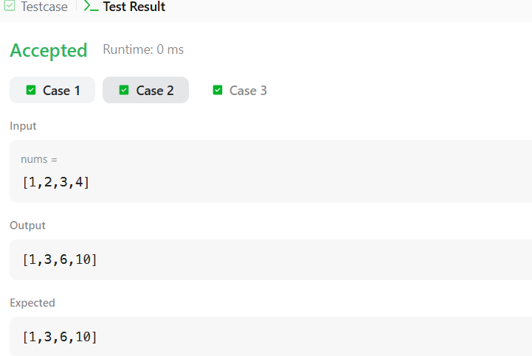

You are given an m x n integer grid accounts where accounts[i][j] is the amount of money the i​​​​​^{​​​​​​th}​​​​ customer has in the j​​​​​^{​​​​​​th}​​​​ bank. Return the wealth that the richest customer has.
A customer's wealth is the amount of money they have in all their bank accounts. The richest customer is the customer that has the maximum wealth.

Example 1:
Input: accounts = [[1,2,3],[3,2,1]]
Output: 6
Explanation:
1st customer has wealth = 1 + 2 + 3 = 6
2nd customer has wealth = 3 + 2 + 1 = 6
Both customers are considered the richest with a wealth of 6 each, so return 6.
Example 2:
Input: accounts = [[1,5],[7,3],[3,5]]
Output: 10
Explanation:
1st customer has wealth = 6
2nd customer has wealth = 10
3rd customer has wealth = 8
The 2nd customer is the richest with a wealth of 10.
Example 3:
Input: accounts = [[2,8,7],[7,1,3],[1,9,5]]
Output: 17

Constraints:
- m == accounts.length
- n == accounts[i].length
- 1 <= m, n <= 50
- 1 <= accounts[i][j] <= 100
Program:
lass Solution {
public int maximumWealth(int[][] accounts) {
int maxWealth = 0;

for (int i = 0; i < accounts.length; i++) {
int wealth = 0;

for (int j = 0; j < accounts[i].length; j++) {
wealth += accounts[i][j];
}

if (wealth > maxWealth) {
maxWealth = wealth;
}
}

return maxWealth;
}
}
Output:
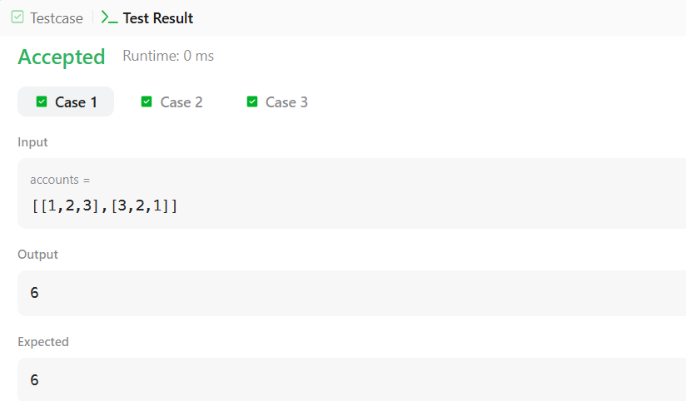
Comparators are used to compare two objects. In this challenge, you'll create a comparator and use it to sort an array. The Player class is provided in the editor below. It has two fields:
- : a string.
- : an integer.
Given an array of Player objects, write a comparator that sorts them in order of decreasing score. If or more players have the same score, sort those players alphabetically ascending by name. To do this, you must create a Checker class that implements the Comparator interface, then write an int compare(Player a, Player b) method implementing the Comparator.compare(T o1, T o2) method. In short, when sorting in ascending order, a comparator function returns if , if , and if .
Declare a Checker class that implements the comparator method as described. It should sort first descending by score, then ascending by name. The code stub reads the input, creates a list of Player objects, uses your method to sort the data, and prints it out properly.
Example
Sort the list as . Sort first descending by score, then ascending by name.
Input Format
The first line contains an integer, , the number of players.
Each of the next lines contains a player's and , a string and an integer.
Constraints

- Two or more players can have the same name.
- Player names consist of lowercase English alphabetic letters.
Output Format
You are not responsible for printing any output to stdout. Locked stub code in Solution will instantiate a Checker object, use it to sort the Player array, and print each sorted element.
Sample Input
5
amy 100
david 100
heraldo 50
aakansha 75
aleksa 150
Sample Output
aleksa 150
amy 100
david 100
aakansha 75
heraldo 50
Program:
import java.util.*;

class Player {
String name;
int score;

Player(String name, int score) {
this.name = name;
this.score = score;
}
}
class Checker implements Comparator<Player> {

public int compare(Player a, Player b) {
if (a.score != b.score) {
return b.score - a.score;
}

return a.name.compareTo(b.name);
}
… }
}
Output:
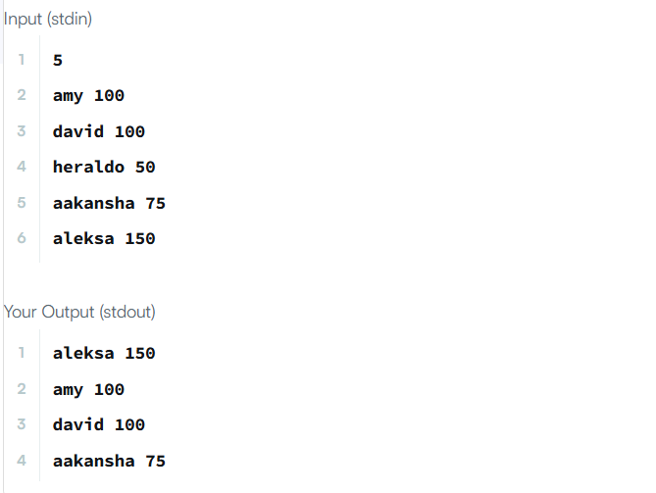

Comparators are used to compare two objects. In this challenge, you'll create a comparator and use it to sort an array.
The Player class is provided for you in your editor. It has fields: a String and a integer.
Given an array of Player objects, write a comparator that sorts them in order of decreasing score; if or more players have the same score, sort those players alphabetically by name. To do this, you must create a Checker class that implements the Comparator interface, then write an int compare(Player a, Player b) method implementing the Comparator.compare(T o1, T o2) method.
Input Format
Input from stdin is handled by the locked stub code in the Solution class.
The first line contains an integer, , denoting the number of players.
Each of the subsequent lines contains a player's and , respectively.
Constraints
- players can have the same name.
- Player names consist of lowercase English letters.
Output Format
You are not responsible for printing any output to stdout. The locked stub code in Solution will create a Checker object, use it to sort the Player array, and print each sorted element.
Sample Input
5
amy 100
david 100
heraldo 50
aakansha 75
aleksa 150
Sample Output
aleksa 150
amy 100
david 100
aakansha 75
heraldo 50
Program:
import java.util.*;
class Checker implements Comparator<Player> {
public int compare(Player a, Player b) {
if (a.score != b.score)
return b.score - a.score;

return a.name.compareTo(b.name);
}
}
class Player{
… }
scan.close();

Arrays.sort(player, checker);
for(int i = 0; i < player.length; i++){
System.out.printf("%s %s\n", player[i].name, player[i].score);
}
}
}
Output:
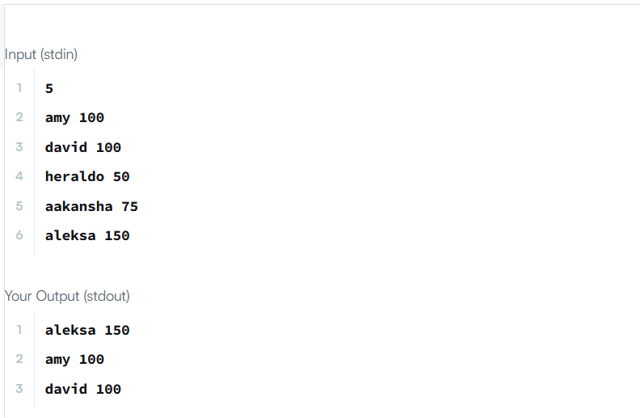

You are given a list of student information: ID, FirstName, and CGPA. Your task is to rearrange them according to their CGPA in decreasing order. If two student have the same CGPA, then arrange them according to their first name in alphabetical order. If those two students also have the same first name, then order them according to their ID. No two students have the same ID.
Hint: You can use comparators to sort a list of objects. See the oracle docs to learn about comparators.
Input Format
The first line of input contains an integer , representing the total number of students. The next lines contains a list of student information in the following structure:
ID Name CGPA
Constraints

The name contains only lowercase English letters. The contains only integer numbers without leading zeros. The CGPA will contain, at most, 2 digits after the decimal point.
Output Format
After rearranging the students according to the above rules, print the first name of each student on a separate line.
Sample Input
5
33 Rumpa 3.68
85 Ashis 3.85
56 Samiha 3.75
19 Samara 3.75
22 Fahim 3.76
Sample Output
Ashis
Fahim
Samara
Samiha
Rumpa
Program:
import java.util.*;

class Student {
private int id;
private String fname;
private double cgpa;

public Student(int id, String fname, double cgpa) {
this.id = id;
this.fname = fname;
this.cgpa = cgpa;
}

public int getId() {
return id;
}

public String getFname() {
return fname;
}

public double getCgpa() {
return cgpa;
}
}

public class Solution {
public static void main(String[] args) {
Scanner in = new Scanner(System.in);
int testCases = Integer.parseInt(in.nextLine());

List<Student> studentList = new ArrayList<>();

while (testCases > 0) {
int id = in.nextInt();
String fname = in.next();
double cgpa = in.nextDouble();

Student st = new Student(id, fname, cgpa);
studentList.add(st);

testCases--;
}

// Custom comparator
Collections.sort(studentList, new Comparator<Student>() {
@Override
public int compare(Student s1, Student s2) {
if (Double.compare(s2.getCgpa(), s1.getCgpa()) != 0) {
return Double.compare(s2.getCgpa(), s1.getCgpa()); // Higher CGPA first
} else if (!s1.getFname().equals(s2.getFname())) {
return s1.getFname().compareTo(s2.getFname()); // Alphabetical order
} else {
return Integer.compare(s1.getId(), s2.getId()); // Smaller ID first
}
}
});

for (Student st : studentList) {
System.out.println(st.getFname());
}
}
}
Output:
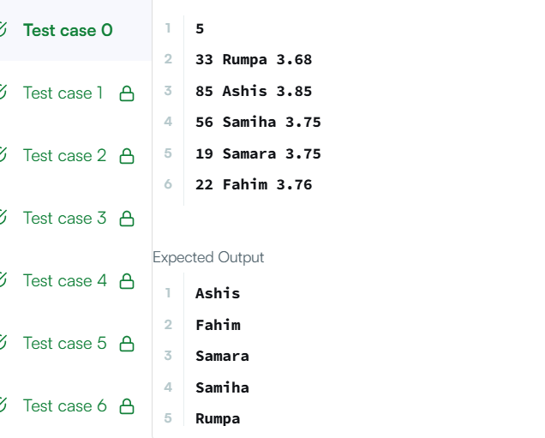

Given an integer array nums, move all the even integers at the beginning of the array followed by all the odd integers.
Return any array that satisfies this condition.

Example 1:
Input: nums = [3,1,2,4]
Output: [2,4,3,1]
Explanation: The outputs [4,2,3,1], [2,4,1,3], and [4,2,1,3] would also be accepted.
Example 2:
Input: nums = [0]
Output: [0]

Constraints:
- 1 <= nums.length <= 5000
- 0 <= nums[i] <= 5000
Program:
class Solution {
public int[] sortArrayByParity(int[] nums) {
int left = 0;

for (int i = 0; i < nums.length; i++) {
if (nums[i] % 2 == 0) {
int temp = nums[left];
nums[left] = nums[i];
nums[i] = temp;
left++;
}
}

return nums;
}
}
Output:
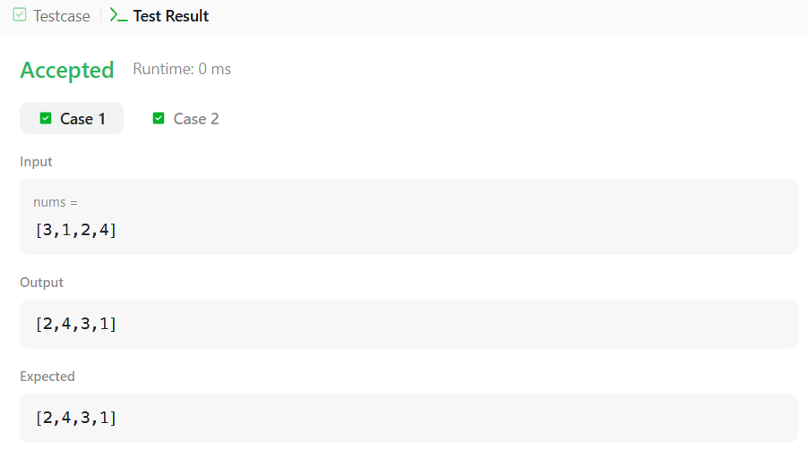

Write the following methods that return a lambda expression performing a specified action:
- PerformOperation isOdd(): The lambda expression must return if a number is odd or if it is even.
- PerformOperation isPrime(): The lambda expression must return if a number is prime or if it is composite.
- PerformOperation isPalindrome(): The lambda expression must return if a number is a palindrome or if it is not.
Input Format
Input is handled for you by the locked stub code in your editor.
Output Format
The locked stub code in your editor will print lines of output.
Sample Input
The first line contains an integer, (the number of test cases).
The subsequent lines each describe a test case in the form of space-separated integers:
The first integer specifies the condition to check for ( for Odd/Even, for Prime, or for Palindrome). The second integer denotes the number to be checked.
5
1 4
2 5
3 898
1 3
2 12
Sample Output
EVEN
PRIME
PALINDROME
ODD
COMPOSITE
Program:
import java.io.*;
import java.util.*;
import java.text.*;
import java.math.*;
import java.util.regex.*;

interface PerformOperation {
boolean check(int a);
}

public class Solution {

public static PerformOperation isOdd() {
return (a) -> {
return a % 2 != 0;
};
}

public static PerformOperation isPrime() {
return (a) -> {
if (a < 2) {
return false;
}

for (int i = 2; i * i <= a; i++) {
if (a % i == 0) {
return false;
}
}

return true;
};
}

public static PerformOperation isPalindrome() {
return (a) -> {
int original = a;
int reverse = 0;

while (a != 0) {
int digit = a % 10;
reverse = reverse * 10 + digit;
a = a / 10;
}

return original == reverse;
};
}

public static void main(String[] args) {

Scanner sc = new Scanner(System.in);

int T = sc.nextInt();

while (T-- > 0) {

int condition = sc.nextInt();
int number = sc.nextInt();

PerformOperation operation;

if (condition == 1) {
operation = isOdd();

if (operation.check(number)) {
System.out.println("ODD");
} else {
System.out.println("EVEN");
}

} else if (condition == 2) {
operation = isPrime();

if (operation.check(number)) {
System.out.println("PRIME");
} else {
System.out.println("COMPOSITE");
}

} else if (condition == 3) {
operation = isPalindrome();

if (operation.check(number)) {
System.out.println("PALINDROME");
} else {
System.out.println("NOT PALINDROME");
}
}
}

sc.close();
}
}

Output:
